Playfair cipher
Generate the key Square(5×5):
- The key square is a 5×5 grid of alphabets that acts as the key for encrypting the plaintext. Each of the 25 alphabets must be unique and one letter of the alphabet (usually J) is omitted from the table (as the table can hold only 25 alphabets). If the plaintext contains J, then it is replaced by I.
- The initial alphabets in the key square are the unique alphabets of the key in the order in which they appear followed by the remaining letters of the alphabet in order.
R | E | D | A | L
T | B | C | F | G
H | I | K | M | N
O | P | Q | S | U
V | W | X | Y | Z

RULES:
- The plaintext is split into pairs of two letters (digraphs). If there is an odd number of letters, a Z is added to the last letter.
Plaintext:
red alert – digraphs
PT-re da le rt
CT-ed al dr th
- Pair cannot be made with same letter. Break the letter in single and add a bogus letter to the previous letter.
hello
he lx lo
- If the letter is standing alone in the process of pairing, then add an extra bogus letter with the alone letter

Plain Text: “helloe”
AfterSplit: ‘he’ ‘lx’ ‘lo’ ‘ez’
Here ‘z’ is the bogus letter.

- If both the letters are in the same column: Take the letter below each one (going back to the top if at the bottom).
PT=rt
CT=th

- If both the letters are in the same row: Take the letter to the right of each one (going back to the leftmost if at the rightmost position).
Plain text: re
cipher text: ed

- If neither of the above rules is true: Form a rectangle with the two letters and take the letters on the horizontal opposite corner of the rectangle.
PT – at
CT- rf

Vigenère Cipher
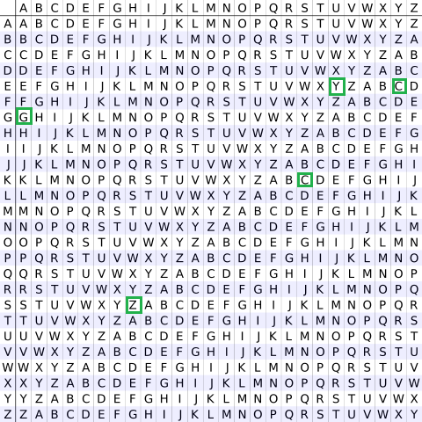
plaintext: wearediscoveredsaveyourself
key: deceptivedeceptivedeceptive
CIPHER:
Encryption
The plaintext(P) and key(K) are added modulo 26.
E_{i} = (P_{i} + K_{i}) mod 26

Decryption
D_{i} = (E_{i} - K_{i} + 26) mod 26

